3MF Editor Build Instructions for VSCode IDE
Prerequisites:
- Windows 10 or later
- Java version 17.0.1 or later installed
- VSCode with Microsoft Extension Pack for Java.
Setup:
- Download the 3mf_Editor from Github.
- From the VSCode File menu, select Open Workspace from File, and select the 3MF.code-wprkspace.
- The 3MF workspace should now be accessible from the project Explorer.
Execution:
- From the Run menu select Run Without Debugging and , select “Java” as debugger. It will execute the “3MF Edit and Test” tool.
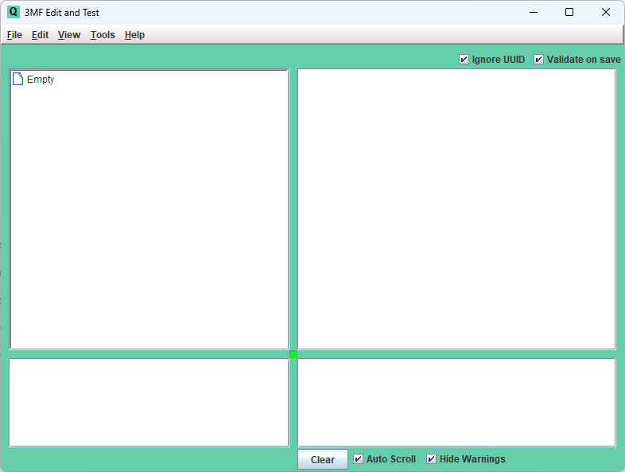
Build JAR File:
- From the JAVA PROJECT folder in the project explorer, click on the Export Jar button:
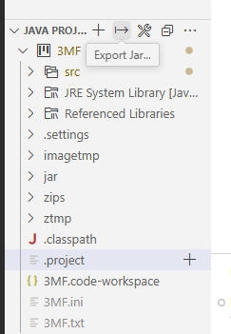
- Select the main class in the center above of VSCode:
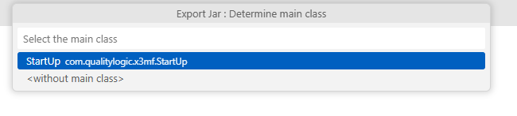
- Select all the run time elements and click OK:
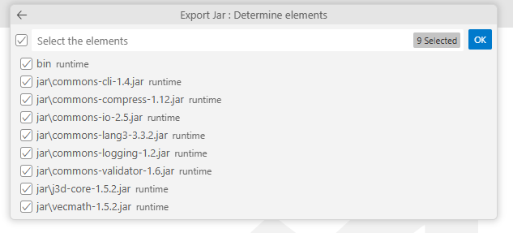
- It will generate 3MF.jar in the 3mf_Editor\3MF folder.
- Just rename it to 3MFedit.jar and now it is ready to execute or move to your execution folder, together with the 3MF Consolidated Schema, from the 3MF Test Suite.

